CHAPTER 10: Transferring and transforming energy
Worksheet 10.1

Skateboard flick cards
Student: Class:

Skate parks are designed to help skateboard riders create the speed and elevation they need to perform tricks. The half-pipe is a U-shaped ramp joined by a flat section at the bottom. In ‘vert’ competitions, the half-pipe is entered from a platform at the top of the ramp. The rider gains speed as they move down the wall. Professional skateboarders use the transfer of energy during a vert manoeuvre to create more ‘airtime’ to perform tricks.
Many energy transformations occur during vert skating in a half-pipe. While moving downwards, a skater’s gravitational potential energy begins to transform into kinetic energy. At the bottom of the half-pipe, the skater has maximum kinetic energy, but little to no gravitational potential energy. The skater’s kinetic energy at the bottom of the half-pipe is equal to their original gravitational potential energy at the top of the ramp. During the climb up the opposite side of the half-pipe, the skater’s kinetic energy begins to transform back into gravitational potential energy. At the very top of the climb, the kinetic energy will have transformed back into gravitational potential energy.

If the skater begins at a certain height on one side of the ramp, how can he or she launch into the air more than four metres above the original starting point?

By crouching going down the ramp and ‘pushing off ’ near the bottom, the skater transfers some of the energy stored in his or her leg muscles to the system. Now, the skater can move higher than the starting level and perform aerial tricks.
To show your understanding of the energy transformations that occur during a vert manoeuvre, create your own vert skating flick card set by following these instructions.
1. Print and label each of the fourteen cards on the next page with one of the following captions:
● gravitational potential energy
● gravitational potential energy transforming into kinetic energy
● kinetic energy
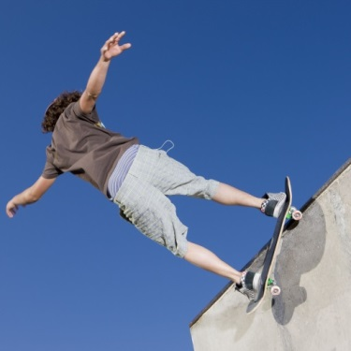
● kinetic energy transforming into gravitational potential energy.
2. Cut out the cards and arrange them into the correct order. The first and last cards will have the skater standing at the top, on the left of the half-pipe.
3. Staple the flick cards down the left-hand side and flick the cards to show a ‘movie’ of the skater in action.
4. As an extension or alternative, make a set of bungee jumping flick cards that show the energy transformations that take place during the jump. Remember that, at times, energy will be stored as elastic potential energy in the bungee cord.

CHAPTER 10: Transferring and transforming energy
Photo: rickbl / 123RF.com
Worksheet 10.1

